ZERO TRUST ARCHITECTURE FOR ENTERPRISE SECURITY

1. Introduction
Nowadays, organizations face many cybersecurity threats from both inside and outside the network. Traditional security systems often trust users within the network, which can create security risks.
Zero Trust Architecture solves this problem by following the idea “Never trust, always verify.” It means every user and device must be checked before getting access to any system or data.
This project focuses on understanding Zero Trust and designing a simple framework using methods like Multi-Factor Authentication (MFA) and Role-Based Access Control (RBAC) to improve security.

2. Steps Followed in the Project
- Understood Zero Trust principles (Never trust, always verify).
- Defined authentication models such as MFA and Role-Based Access Control (RBAC).
- Designed a Zero Trust framework including identity verification, micro-segmentation, and encryption.
- Simulated an enterprise environment using tools like VMware or Docker (conceptually).
- Implemented access control policies using Identity and Access Management (IAM).
- Tested security by simulating insider and external threats.
- Documented results and suggested improvements.

3. Zero Trust Principles
Zero Trust is based on the following principles:
- Never trust any user or device by default
- Always verify identity before granting access
- Provide limited access based on need
- Continuously monitor user activity

4. Authentication Models
Multi-Factor Authentication (MFA)
MFA requires users to verify their identity using multiple methods such as:
- Password
- One-Time Password (OTP)
- Biometric verification
Role-Based Access Control (RBAC)
RBAC allows access based on user roles:
- Admin → Full access
- Employee → Limited access
This ensures users can only access what is necessary.

5. Zero Trust Framework Design
The designed framework includes:
- Identity Verification – Verifying user credentials before access
- Micro-Segmentation – Dividing the network into smaller secure parts
- Encryption – Protecting data during transmission
- Continuous Monitoring – Tracking user activities

6. Simulation of Enterprise Environment
A simulated enterprise environment was considered using virtualization tools like VMware or Docker.
The system included:
- Multiple users (admin and employees)
- Secure resources (data, applications)
- Authentication checkpoints
This helped in understanding how Zero Trust works in real-world scenarios.

7. Access Control Implementation (IAM)
Identity and Access Management (IAM) was used to define access rules.
- Users were required to verify identity using MFA
- Access was granted based on roles (RBAC)
- Unauthorized access attempts were restricted

8. Security Testing
The system was tested by simulating:
- Insider Threat – Employee trying to access restricted data
- External Threat – Unauthorized user attempting login
In both cases, the system required verification and blocked unauthorized access.

9. Results and Observations
- Unauthorized users were not able to access the system
- MFA improved authentication security
- RBAC ensured limited and controlled access
- Zero Trust model reduced security risks significantly

10. Suggestions for Improvement
- Implement real-time monitoring tools
- Use advanced threat detection systems
- Regularly update access policies
- Provide cybersecurity training to employees

11. Conclusion
This project demonstrates that Zero Trust Architecture is an effective approach for securing enterprise systems. By verifying every user and limiting access, organizations can reduce the risk of cyber attacks and improve overall security.

12. Framework Diagram
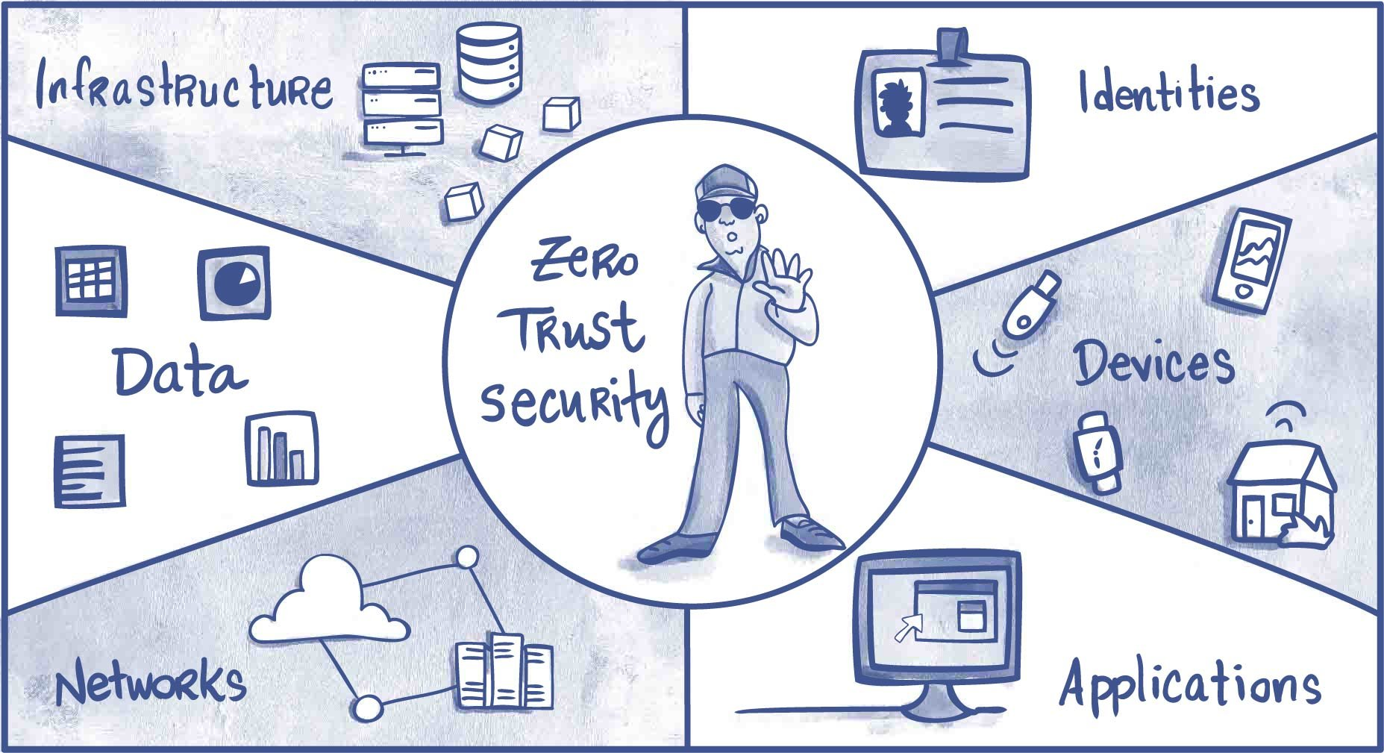
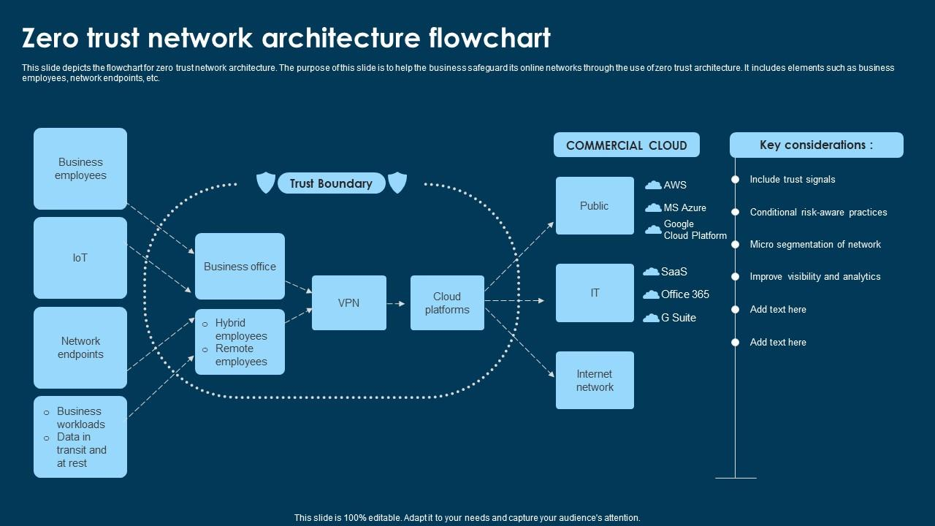
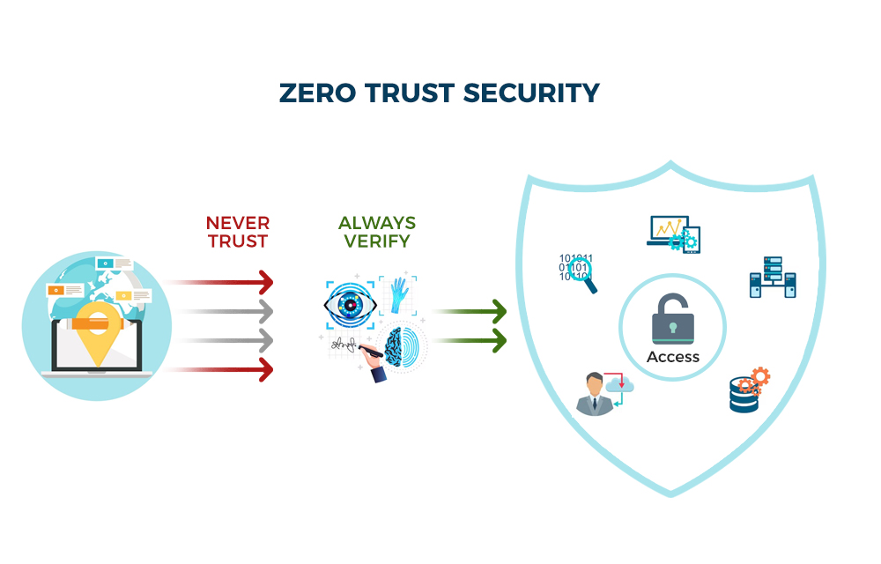
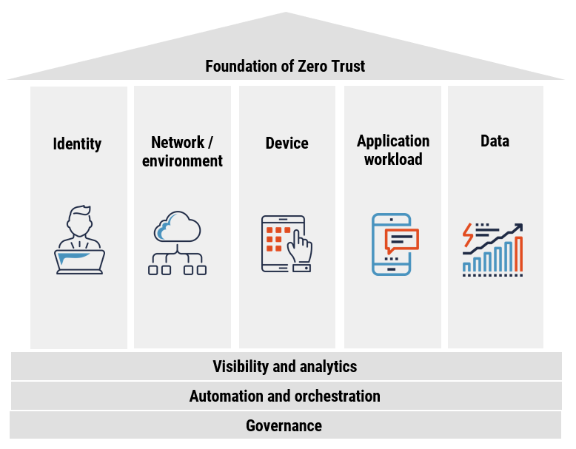
Zero Trust Architecture Framework

13. Best Practices
- Always verify user identity
- Use Multi-Factor Authentication
- Apply Role-Based Access Control
- Encrypt sensitive data
- Monitor user activity regularly

